Mail Storage - Mailbox System

📦 What Is Mail Storage - Mailbox System?
# Source: AI Source: Provided by: [Data Path: Persons Table -> ID Column: 1, Name_En Column: Motasem Essam] -> From: [ChatGPT] on [1/21/2026]
Mail storage or the mailbox system is the part of a mail server that stores incoming emails on disk, so they can be read later by users through email clients (IMAP, POP3, or Webmail).
It acts like the hard drive of your email system — where all the actual email files, headers, attachments, and metadata are saved.

🧠 Why Is It Important?
# Source: AI Source: Provided by: [Data Path: Persons Table -> ID Column: 1, Name_En Column: Motasem Essam] -> From: [ChatGPT] on [1/21/2026]
When an email is received:
- The Mail Transfer Agent (MTA) accepts it.
- The Mail Delivery Agent (MDA) places it into mail storage.
- The IMAP/POP3 server accesses that storage so the user can read their mail.
No mail storage = no inbox.

📁 Common Mail Storage Formats
# Source: AI Source: Provided by: [Data Path: Persons Table -> ID Column: 1, Name_En Column: Motasem Essam] -> From: [ChatGPT] on [1/21/2026]
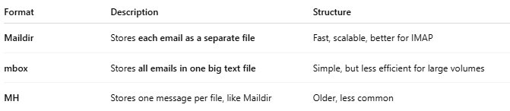

Format | Description | Structure
Maildir | Stores each email as a separate file | Fast, scalable, better for IMAP
mbox | Stores all emails in one big text file | Simple, but less efficient for large volumes
MH | Stores one message per file, like Maildir | Older, less common

📌 Maildir Structure Example
# Source: AI Source: Provided by: [Data Path: Persons Table -> ID Column: 1, Name_En Column: Motasem Essam] -> From: [ChatGPT] on [1/21/2026]
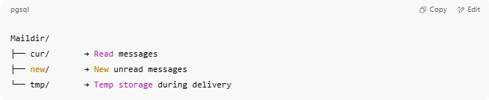

Maildir/
├── cur/ → Read messages
├── new/ → New unread messages
└── tmp/ → Temp storage during delivery

Each message is a separate .eml file.

📌 mbox Example (single file)
# Source: AI Source: Provided by: [Data Path: Persons Table -> ID Column: 1, Name_En Column: Motasem Essam] -> From: [ChatGPT] on [1/21/2026]
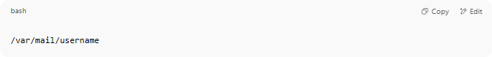
/var/mail/username

Inside this file:
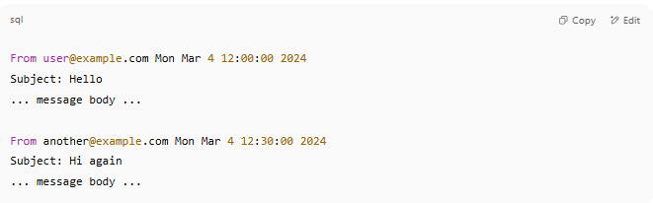
From user@example.com Mon Mar 4 12:00:00 2024
Subject: Hello
... message body ...

From another@example.com Mon Mar 4 12:30:00 2024
Subject: Hi again
... message body ...

🔒 Where It's Stored
# Source: AI Source: Provided by: [Data Path: Persons Table -> ID Column: 1, Name_En Column: Motasem Essam] -> From: [ChatGPT] on [1/21/2026]
- On the server’s filesystem (e.g., /var/mail/, /home/user/Maildir/)
- Accessed by Dovecot, Postfix, IMAP/POP3 clients

📥 What Happens When You Get Mail
# Source: AI Source: Provided by: [Data Path: Persons Table -> ID Column: 1, Name_En Column: Motasem Essam] -> From: [ChatGPT] on [1/21/2026]
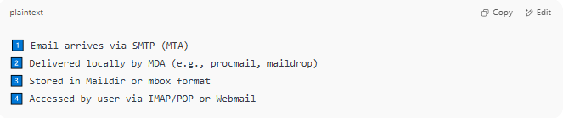

1️⃣ Email arrives via SMTP (MTA)
2️⃣ Delivered locally by MDA (e.g., procmail, maildrop)
3️⃣ Stored in Maildir or mbox format
4️⃣ Accessed by user via IMAP/POP or Webmail

✅ Summary
# Source: AI Source: Provided by: [Data Path: Persons Table -> ID Column: 1, Name_En Column: Motasem Essam] -> From: [ChatGPT] on [1/21/2026]
Mail storage is where incoming emails are physically saved on a mail server.
It uses formats like Maildir (folder of files) or mbox (single file).
It works with other parts of the mail system to store, organize, and retrieve messages.

